TASK 7 – Evaluate Process Control System Calls
Test environment: Ubuntu 24.04.4 LTS, Linux kernel 6.18, gcc 13.3.0, compiled with gcc -std=c11 -Wall -Wextra -pthread. Timings were taken inside a single-CPU virtual machine; absolute times will differ on your machine, the trends are what matter.

1. What fork(), exec(), wait() and exit() Do
Call | What it does | Return value and effect
fork() | Creates a new process (the child) that is a copy of the calling process (the parent): same code, same data, same open files, with a new process ID. Memory is shared copy-on-write. | Returns the child’s pid in the parent, 0 in the child, and -1 on error. After it returns, two processes run the same code.
exec() family (execlp, execv, ...) | Replaces the program running in the current process with a new program loaded from a file. The process keeps its pid and its open files, but its code, data, heap and stack are replaced. | Does not return on success, because the old program no longer exists. Returns -1 only on failure (for example, the program was not found). That is why the code after exec is exit(127).
wait() / waitpid() | Makes the parent sleep until a child terminates, then collects the child’s exit status and lets the kernel free the child’s process-table entry (reaping). | Returns the pid of the child that ended and fills in a status word. WIFEXITED and WEXITSTATUS read the exit code; WIFSIGNALED and WTERMSIG report death by a signal.
exit() / _exit() | Terminates the calling process. The kernel closes its files, frees its memory and sends SIGCHLD to its parent. The low 8 bits of the exit code are saved for the parent. | Does not return. exit() first runs atexit handlers and flushes stdio buffers; _exit() leaves immediately and does not flush stdio buffers.

2. How a Shell Runs a Command and Gets Its Exit Status
- The shell reads a command line, for example expr 6 * 7, and splits it into a program name and arguments.
- The shell calls fork(). Now there are two copies of the shell.
- In the child, the shell sets up redirections and pipes (it can change the child’s file descriptors here, without affecting itself), then calls exec() with the program, so the child becomes expr.
- In the parent, the shell calls waitpid() and sleeps until the command finishes.
- The child runs, writes its output to the inherited standard output and calls exit() with a code (0 means success, any other value means failure).
- The kernel wakes the parent. waitpid() returns the status, and WEXITSTATUS(status) gives the exit code, which the shell stores (as $? in a real shell) and which scripts can test.
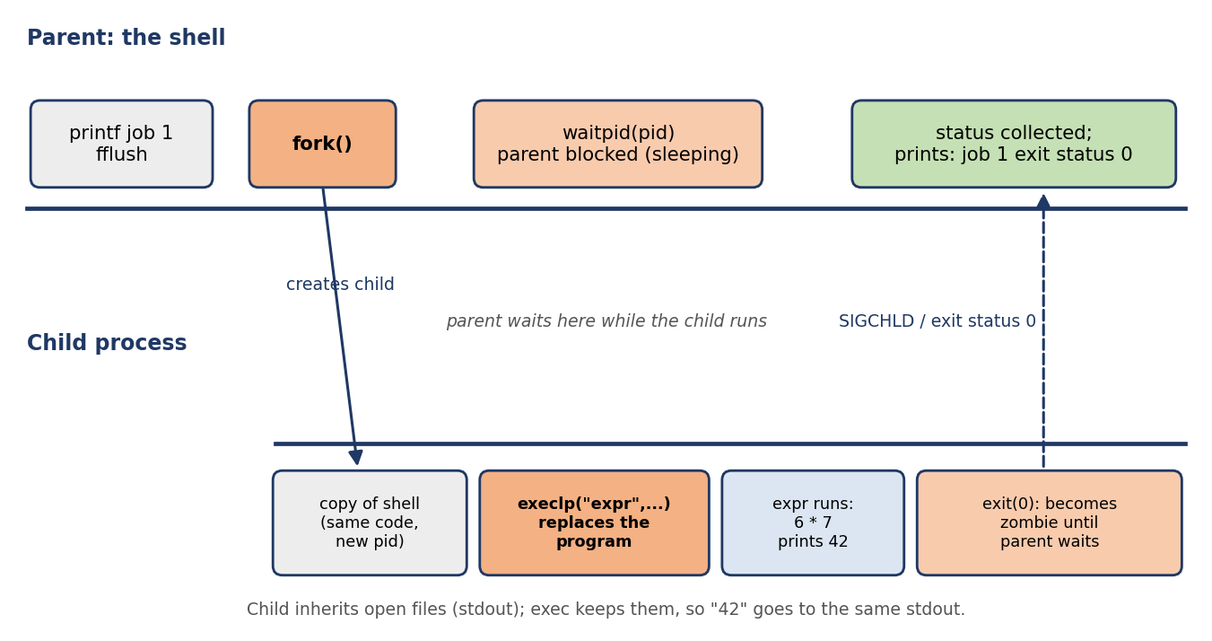
Figure 1: How the shell runs job 1 (expr 6 * 7) with fork(), execlp() and waitpid()

3. Zombie and Orphan Processes
 | Zombie process | Orphan process
Definition | A child that has exited but whose parent has not yet called wait(). It uses no CPU or memory, but its process-table entry stays so that the exit status can be delivered. | A child that is still running after its parent has exited.
How the OS deals with it | The entry is removed when the parent calls wait() or waitpid(). If the parent exits without waiting, the zombie is re-parented to init, which reaps it. A parent can also ignore SIGCHLD (or set SA_NOCLDWAIT) so the kernel reaps children automatically. | The kernel re-parents the orphan to init (process 1) or to the nearest subreaper process. init calls wait() on its adopted children, so they are cleaned up when they end.
Problem if ignored | A long-running parent that never waits fills the process table with zombies, until no new process can be created. | None in itself. The orphan keeps running normally (daemons are created on purpose this way). Its parent pid changes to 1.
How to see it | ps shows state Z (defunct) | getppid() returns 1 after adoption
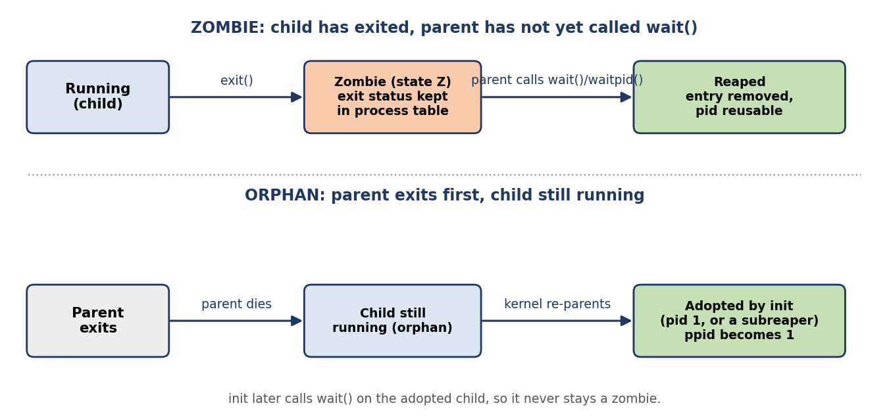
Figure 2: Zombie and orphan processes and how the kernel resolves them

Demonstration (run on Linux)
zombie.c forks a child that exits at once, while the parent sleeps for 3 seconds without calling wait(). ps then shows the child in state Z, and after waitpid() it is gone:
child 655: exiting now
parent 654: child is 655; sleeping 3 s without wait()
--- ps while the child is un-reaped:
PID PPID STAT COMMAND
655 654 Z zombie
parent: reaped child, exit status 5
--- ps after waitpid:
PID PPID STAT COMMAND

orphan.c lets the parent exit first. The child’s parent pid changes from the original parent to 1:
child 661: parent is 660
parent 660: exiting before the child
child 661: parent is now 1 (adopted)

4. Why fork() Followed by exec() Instead of a Single “Create Process” Call
- Flexibility. Between fork() and exec() the child is still a copy of the shell, so the shell can change the child’s environment and only the child’s: redirect standard input and output to files (command > file), connect pipes (a | b), change the working directory, set environment variables, reset signal handlers, drop privileges or set resource limits. With a single create-process call, every one of these would need a parameter, and the call would need a huge argument list.
- Simplicity and orthogonality. fork() and exec() are two small, independent operations that can be combined in many ways. A process can fork without exec (a server creating worker copies) or exec without fork (replacing itself with another program).
- Inheritance. The child inherits open files, so the child’s standard output is already the shell’s output or file. No special code is needed to pass them.
- Cost and the alternative. fork() is not free (see Section 7), and a combined call such as posix_spawn() exists for the common case. A single call is simpler to use but less flexible, which is why UNIX shells still use fork and exec.

5. Complete the Code: TODO 1
The pasted skeleton did not declare pid or status, so they are declared inside the TODO 1 block. The program below is the complete shell_jobs.c; the lines outside the TODO block are unchanged.
#define _POSIX_C_SOURCE 200809L
#include <stdio.h>
#include <stdlib.h>
#include <unistd.h>
#include <sys/wait.h>

int main(void) {
printf("shell: running job 1\n");
fflush(stdout); /* empty the buffer before fork() */

// TODO 1: Create a child with fork(). In the child, replace the program with
// execlp("expr", "expr", "6", "*", "7", (char *)NULL) and exit(127) if exec
// fails. In the parent, wait for the child with waitpid() and print "job 1 exit status N" using WEXITSTATUS
pid_t pid;
int status;
pid = fork();
if (pid < 0) { /* fork failed */
perror("fork");
return 1;
}
if (pid == 0) { /* child: become "expr 6 * 7" */
execlp("expr", "expr", "6", "*", "7", (char *)NULL);
exit(127); /* only reached if exec failed */
}
waitpid(pid, &status, 0); /* parent: wait for the child */
printf("job 1 exit status %d\n", WEXITSTATUS(status));

printf("shell: running job 2\n");
fflush(stdout);
pid = fork();
if (pid == 0) _exit(3); /* a child that fails with code 3 */
waitpid(pid, &status, 0);
printf("job 2 exit status %d\n", WEXITSTATUS(status));
return 0;
}

5.1 Execution and output
$ gcc -std=c11 -Wall -Wextra -pthread shell_jobs.c -o shell_jobs
$ ./shell_jobs
shell: running job 1
42
job 1 exit status 0
shell: running job 2
job 2 exit status 3

The output matches the expected output. Job 1 is a real command: the child is replaced by expr, which prints 42 and returns 0. Job 2 is a child that calls _exit(3), and the parent reads the code 3 with WEXITSTATUS. The same output appears when the output is redirected to a file, because the original program flushes before each fork.

6. Why stdout Is Flushed before Each fork()
When stdout is a terminal, the C library buffers it by line. When stdout is a file or a pipe, it buffers it fully (typically 4096 bytes), and text stays in a buffer in the process’s user memory until the buffer fills, fflush() is called, or the process ends normally through exit() or return from main.
fork() copies the whole process, including that buffer. If unflushed text is in the buffer at the time of fork(), the parent and the child each hold a copy, and each can write it out later, so the text can be printed twice. Flushing before fork() empties the buffer, so the child starts with nothing to repeat. This also puts the shell’s messages in the right order relative to the child’s output, because the child writes to the same file directly.

6.1 Experiment: remove the second fflush(stdout), change _exit(3) to exit(3), redirect to a file
The change to shell_jobs.c is two lines:
--- shell_jobs.c
+++ shell_jobs_exp.c
- fflush(stdout); (second fflush removed)
- if (pid == 0) _exit(3);
+ if (pid == 0) exit(3);

Run with the output redirected: ./sj_exp > out_exp.txt; cat -n out_exp.txt gives:
1 shell: running job 1
2 42
3 job 1 exit status 0
4 shell: running job 2
5 job 1 exit status 0
6 shell: running job 2
7 job 2 exit status 3

Explanation. With the output going to a file, stdout is fully buffered. When the parent runs printf("job 1 exit status 0\n") and printf("shell: running job 2\n"), both lines stay in the buffer because the second fflush is gone. fork() then copies this buffer into the child. The child calls exit(3), which (unlike _exit) runs the library’s clean-up and flushes stdio buffers, so the child writes both lines to the file (lines 3 and 4). The parent then waits, prints “job 2 exit status 3”, and its own exit flushes its copy of the buffer (lines 5, 6 and 7). So “shell: running job 2” appears twice, and “job 1 exit status 0” appears twice for the same reason.
strace -f -e trace=write confirms it: the child (second process) makes one write() of 41 bytes containing both lines, and the parent later makes one write() of 61 bytes containing both lines plus the new line.
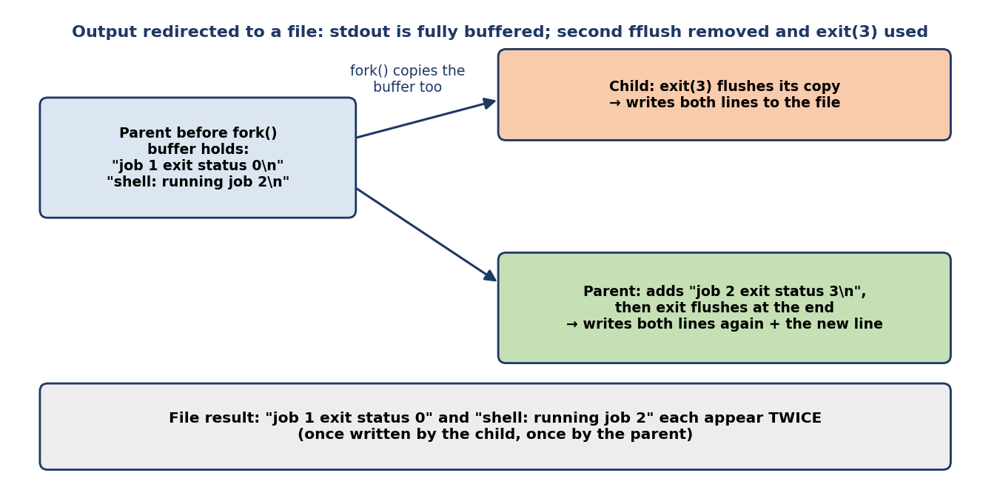
Figure 3: How fork() duplicates unflushed stdio buffer contents
Both changes are needed to see the duplicate. With only the second fflush removed and _exit(3) kept, the output is correct, because _exit does not flush the child’s copy. With only exit(3) and the fflush kept, the output is also correct, because the buffer was empty when fork() ran. On a terminal (line-buffered stdout) each line is written as soon as the newline is printed, so the buffer is empty at fork() and the problem does not appear either. The duplicate shows only when stdout is a file or a pipe and the program calls exit() in the child without flushing first.

7. Alternative Concept and Complexity Analysis
Alternative concept: the shell starts commands with posix_spawn(), or with threads, instead of fork() followed by exec().

7.1 posix_spawn()
posix_spawn() creates the new process and loads the new program in one call, without running user code in the child in between. Redirections, signal masks and the working directory are described in advance with file-action and attribute objects. On Linux it is implemented with clone(CLONE_VM | CLONE_VFORK), so the child borrows the parent’s address space until it execs, and nothing is copied.
pid_t pid;
char *argv[] = { "expr", "6", "*", "7", NULL };
int rc = posix_spawnp(&pid, "expr", NULL, NULL, argv, environ);
if (rc != 0) { /* spawn failed: rc is an errno value */ }
int status; waitpid(pid, &status, 0);
printf("job 1 exit status %d\n", WEXITSTATUS(status));

7.2 Threads
A thread is created with pthread_create(). It runs a function inside the same process, so it cannot run a separate program by itself. To run an external command from a thread, the program would still need fork and exec or posix_spawn. Threads are suitable for running many tasks written as functions inside one program, not for starting independent programs the way a shell does.

7.3 Time to start 1,000 commands (measured)
Each method started 1,000 commands, one after another, and waited for each one (best of 3 runs). The command was /bin/true. “fork only” has the child exit at once with no exec, and the thread runs a tiny function; these are not commands, they show only the cost of creating the execution unit.
Method (parent has almost no memory) | Total for 1,000 (ms) | Per command (µs)
fork() + exec() + waitpid() | 1,102.3 | 1,102.3
posix_spawn() + waitpid() | 1,034.9 | 1,034.9
fork() only, child exits (no exec) | 70.0 | 70.0
pthread_create() + pthread_join() (tiny function) | 12.2 | 12.2
About 1.1 seconds for 1,000 commands with fork and exec, and about 1.0 second with posix_spawn. Most of this time is not process creation, but loading the new program (exec, the dynamic linker and C library start-up) and tearing the process down. That is why the difference between fork+exec and posix_spawn is small (about 6%) when the parent is small. Threads are about 90 times cheaper than starting a process, but they do not start a new program.

7.4 Memory copied or shared (copy-on-write)
fork() does not copy the parent’s memory pages. It copies the page tables and marks the pages read-only; a page is copied only when either process writes to it (copy-on-write). The cost of fork() therefore grows with the size of the parent’s memory, because of the page-table copy. posix_spawn() (via CLONE_VM) copies nothing. The parent was made to touch 0, 64, 256 and 1,024 MiB of memory (4 KiB pages), and the cost of one call was measured over 200 calls:
Memory touched by the parent | fork() alone (µs) | posix_spawn() of /bin/true, including exec (µs)
0 MiB | 68.8 | 1,035.1
64 MiB | 1,063.8 | 1,073.1
256 MiB | 4,005.0 | 1,051.4
1,024 MiB | 16,098.9 | 1,028.2
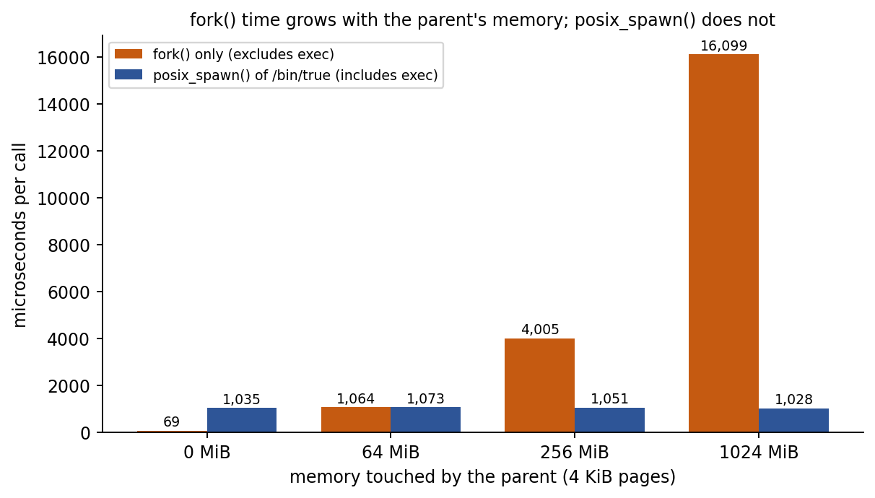
Figure 4: Time per call versus the parent’s memory size (measured)
fork() time rises almost in proportion to the parent’s memory (about 16 ms for 1 GiB), while posix_spawn() stays at about 1 ms whatever the size of the parent, because it shares the address space instead of duplicating page tables. A shell or a large database server that starts many commands pays this cost on every fork. Complexity: fork is O(m) in the parent’s mapped memory m (page tables), plus O(w) for the pages later written (copy-on-write faults, w = pages written). posix_spawn is O(1) in m. Threads share all memory at O(1) cost, with no copy at all. With huge pages the page tables are much smaller; the first run of the benchmark (default settings, large pages enabled) showed almost no growth in fork time, so the effect depends on the page size.

7.5 Isolation between commands
Aspect | fork + exec / posix_spawn (processes) | Threads
Address space | Separate. One command cannot read or write another’s memory. | Shared. Any thread can read or overwrite any other thread’s data.
Effect of a crash | A command that crashes (segmentation fault) only ends itself. The shell sees the signal in the status and continues. | A crash in one thread kills the whole process, including the shell and every other command.
Open files and descriptors | Inherited as copies, then each process can close or redirect its own without affecting the others | Shared table. A close or redirect in one thread affects all threads.
Environment, current directory, signals | Per process. Changing them in a command does not change the shell. | Shared, so a change by one command changes the shell and all others.
Security and permissions | Each process can have its own user ID, limits and sandbox | All threads have the same user ID and rights
Communication | Needs pipes, files or sockets, which is slower but explicit | Fast, through shared memory, but needs locks to avoid data races

7.6 Overall judgement
Criterion | fork + exec | posix_spawn | Threads
Time to start 1,000 commands | About 1.10 s | About 1.03 s | About 0.012 s, but they cannot run another program
Cost as the parent grows | Rises (O(m)) | Constant (O(1)) | Constant (O(1))
Memory shared or copied | Copy-on-write copy of page tables | Address space borrowed, nothing copied | Everything shared
Isolation | Strong | Strong | None
Flexibility between create and run | Maximum (arbitrary code in the child) | Limited to the supported actions | Not applicable
Conclusion: for a command shell, process isolation is essential, so threads are not a suitable replacement. posix_spawn() gives the same isolation with a cost that does not depend on the size of the parent, which makes it the better choice for a large server process that launches many short commands and needs only simple redirections. fork() followed by exec() remains the most flexible method, and is the right choice for a general shell that sets up pipelines and arbitrary redirections between the two calls.

